**Week 2 Mandatory hands-on Junit, Mockito, SLF4J**

Student Name: Jitesh Sen

Email: [jiteshsen2002@gmail.com](mailto:jiteshsen2002@gmail.com)

Superset ID: 6387362

The **week2-testing** codebase is organized as:

* main/java → holds the main business logic classes
* test/java → contains unit tests and mock tests
* pom.xml → manages dependencies (JUnit, Mockito, SLF4J, Logback)

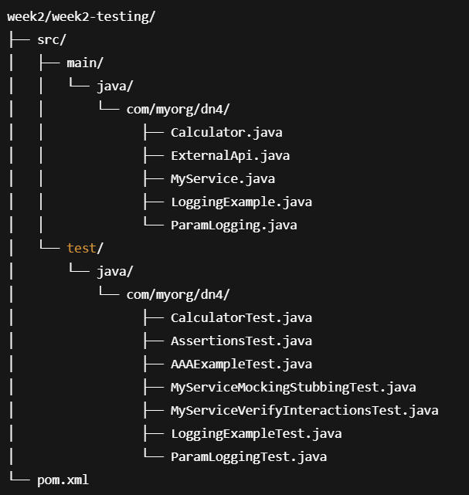

**JUnit Exercises:**

* *CalculatorTest.java*: Successfully validates the basic arithmetic operations of the Calculator class using JUnit assertions.
* *Output*:

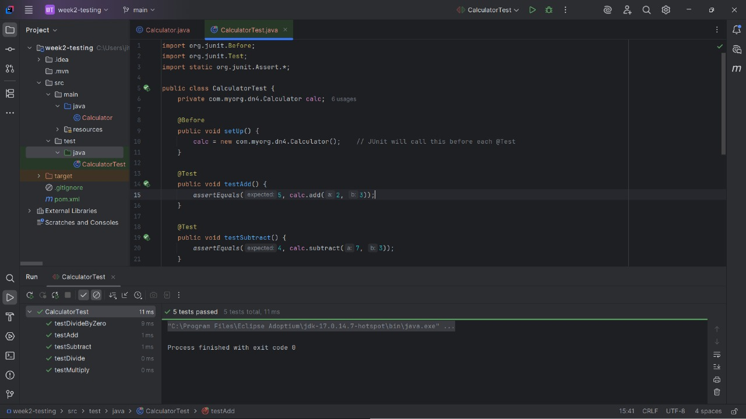

* *AssertionsTest.java*: Demonstrates various JUnit assertions like assertTrue, assertFalse, assertNull, and assertNotNull.
* *Output*:
* 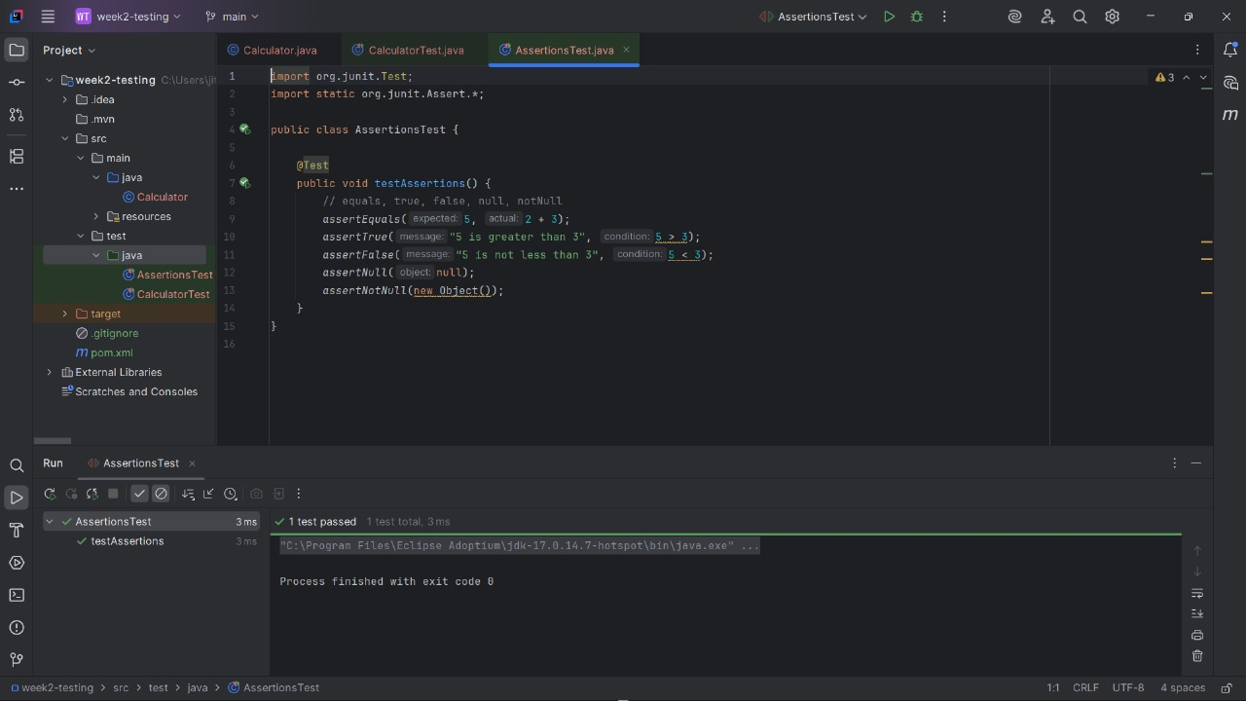
* *AAAExampleTest.java*: Confirms correct Arrange‑Act‑Assert pattern along with setup and teardown lifecycle in JUnit.
* *Output*:

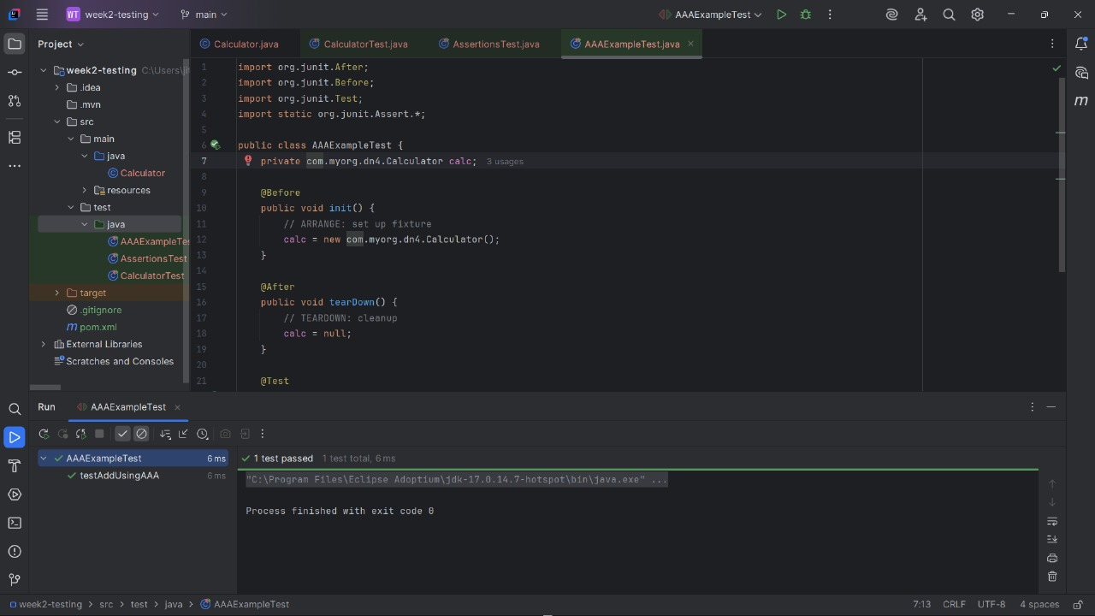

**Mockito Exercises:**

* *MyServiceMockingStubbingTest.java*: Mocks and stubs the ExternalApi to verify controlled responses and interactions.
* *Output*:
* 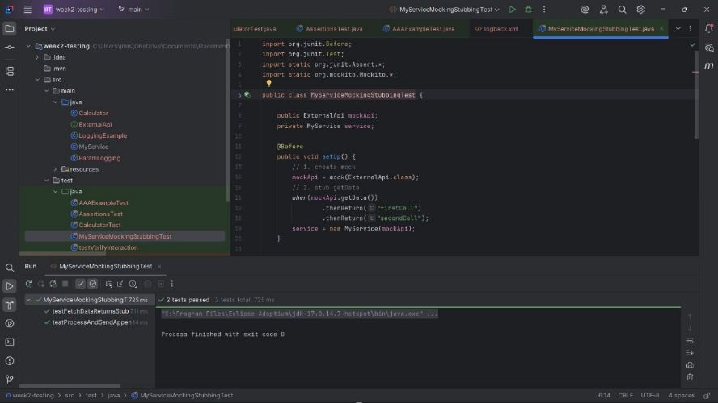
* *MyServiceVerifyInteractionsTest.java*: Validates the order of method calls, verifies method calls, and correctly handles exceptions on void methods using Mockito.
* *Output*:

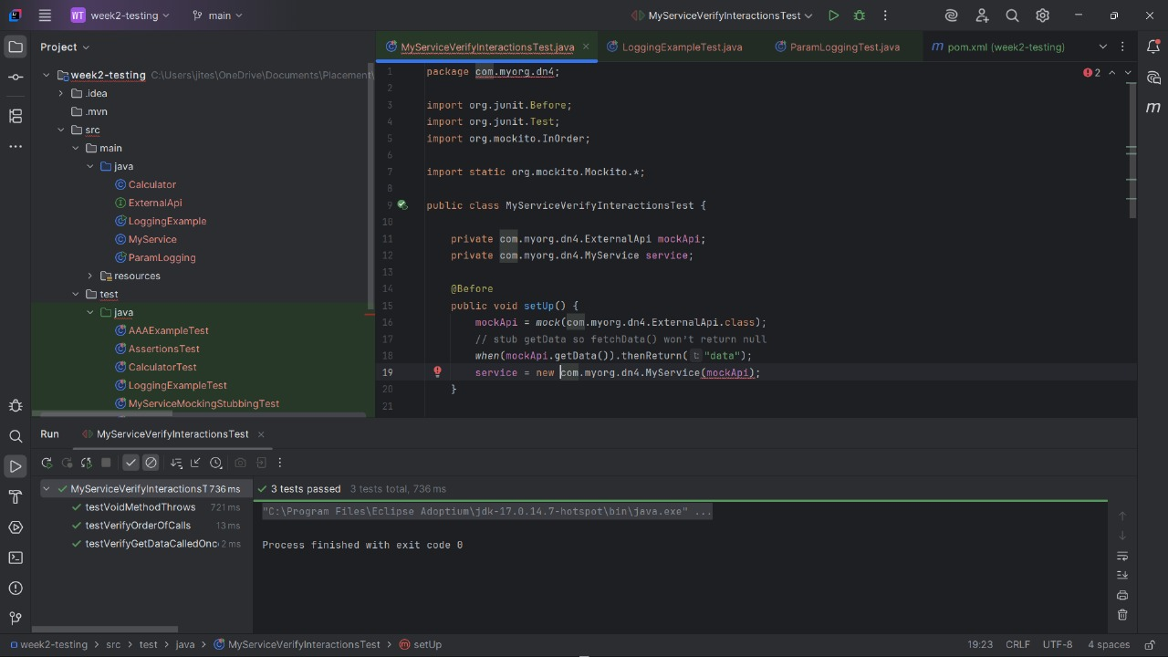

**SLF4J / Logging Exercises:**

* *LoggingExampleTest.java*: Confirms that error and warning messages are logged by LoggingExample using Logback’s ListAppender.
* *Output*:

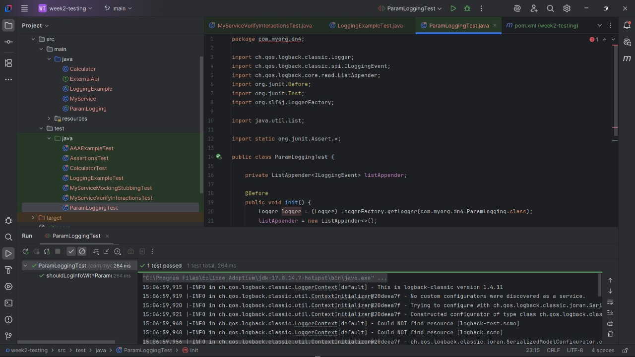

* *ParamLoggingTest.java*: Verifies that parameterized log messages in ParamLogging are logged correctly with expected values.
* *Output*:

